**Control of Temperature using Fuzzy System Technique**

**A**

**PROJECT REPORT**

**Submitted for**

**IT 3140 (Soft Computing)**

**Internal Assessment Component**

**Submitted by Submitted To**

**Riyanshi Bohra & Vanshika Goyal Dr. Sulabh Bansal**

**199302110 & 199302049 Assistant Professor (Senior Scale)**  Dept. of Computers and Communication Dept. of Information Technology



Information Technology

MANIPAL UNIVERSITY JAIPUR

JAIPUR-303007

RAJASTHAN, INDIA

December 2021

**INTRODUCTION-**

The aim of the temperature control is to heat the system up to delimitated temperature, afterward hold it at that temperature in insured manner. Fuzzy Logic Controller (FLC) is best way in which this type of precision control can be accomplished by controller. Here we have developed temperature control system using fuzzy logic. Control theory techniques are the root from which convention controllers are deducted. The desired response of the output can be guaranteed by the feedback controller. Fuzzy control is based on fuzzy logic. A logical system that is much closer in spirit to human thinking and natural language than traditional crisp logical systems. The fuzzy logic variables are not described as true or false values. Instead, values range in degree between 0-1, true-false or yes-no.

**BACKGROUND MATERIAL -**

**Theory used**

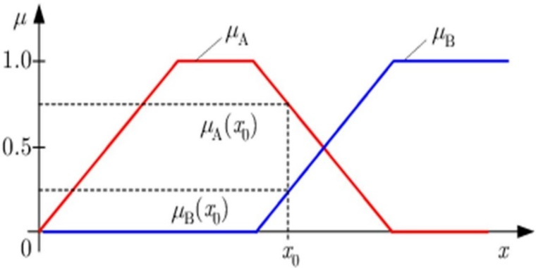An algorithm that transforms sensor inputs into corresponding control values is called a control strategy. If traditional control methodology cannot be applied, how can one control? Often there is an additional expert knowledge available for example, expert operators who successfully control the desired system. Expert operators know how to operate a plant. Therefore, it is desirable to extract the control rules from the expert and use this knowledge in an automatic control system. The examples show us that good knowledge of a plant to be controlled is beneficial. To analyse a stability model is even necessary. But more important, the PID controller design step gives us a tuning Kc, Ti and Td that we could transfer to the fuzzy controller. There the PID controller constitutes a reference for assessment of the performance of the fuzzy controller.

It is quite difficult to design a fuzzy controller because it is in nonlinear and nonlinear systems are more or less unpredictable. Instead of propose to stay as long as possible in the linear domain, reflected in the proposed deign procedure. The idea is to start from PID control design a linear fuzzy controller that is equivalent to a pre-designed PID controller. At this point all the results from linear control theory can be applied including tuning methods and stability calculations. In the next phase the fuzzy controller is made nonlinear.

FUZZY SYSTEMS

System of variable which is related using fuzzy logic so as to create a fuzzy system. Fuzzy controller uses defined rules to control a fuzzy system based on the of known values of input variables. The first step in designing a fuzzy system with the fuzzy system designer is to constitute the input and output linguistic variables for the system. Traditional Boolean logic consists of two values because a member either belongs to a set or doesn’t. Values of one and zero symbolize the membership to the set with one representing accurate membership and zero can be defined as no membership. Fuzzy logic bring into use for partial membership or a degree of membership that may be any value along the operation of zero to one.

FUZZY SETS

Fuzzy set theory is an extension of classical set theory. Under this aspect the term of the membership function is introduced. The operations sets are introduced and explained and illustrated using membership functions. Starting with elementary operators for fuzzy sets more complicated operators for modelling of rule bases and reasoning processes are introduced.

## 

MEMBERSHIP FUNCTION

The membership of the elements is defined in the membership function µ(x). The membership of the elements x of the base is constituted in the fuzzy set A. For µ(x) a widely class of functions can be taken. Reasonable functions are usually piece by piece linear functions, such as triangular or trapezoidal functions.

There are two different ways to perform a membership function: continuous and discrete. The continuous fuzzy set A is described with the continuous membership function µ(x).

A trapezoidal membership function is a piece by piece linear ,continuous function, controlled by four parameters ; {a, b, c, d}

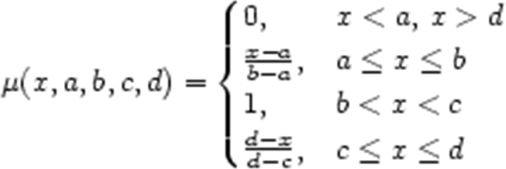

Figure-2: the parameters

The parameters a ≤ b ≤ c ≤ d define four breakpoints, designated as follows: left footpoint(a), left shoulderpoint(b), right shoulderpoint(c), and right footpoint(d). A trapezoidal membership function is illustrated in Figure-2.

A triangular membership functionis also piece by piece wise linear. The trapezoidal membership function is derived by merging two shoulderpoints into one, setting b=c. If it requires to smooth out that situation differential versions of the trapezoidal and triangular membership functions can be achieved by replacing the linear segments corresponding to intervals a ≤ x ≤ b and c ≤ x ≤ d by a nonlinear function.

FUZZY CONTROL IN DETAIL

Fuzzy controller has very simple structure. The structure is made up of an input stage, a processing stage and output stage. The input stage maps sensors or other inputs for instance switches, thumb wheels etc. to the appropriate membership and truth values. The processing begin each suitable rule and achieve a result for each. Then combines the results of the rules. As a result of is the output stage converts the combined result back into a specific control output value.

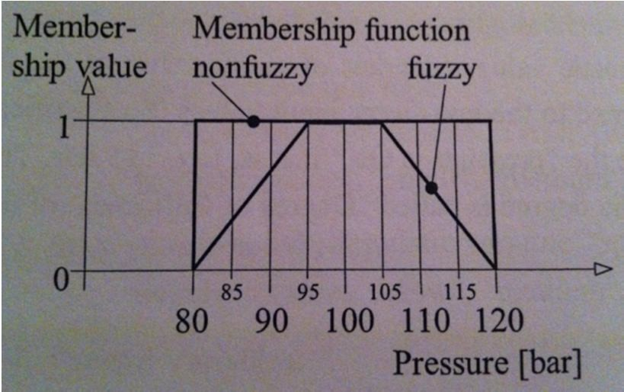

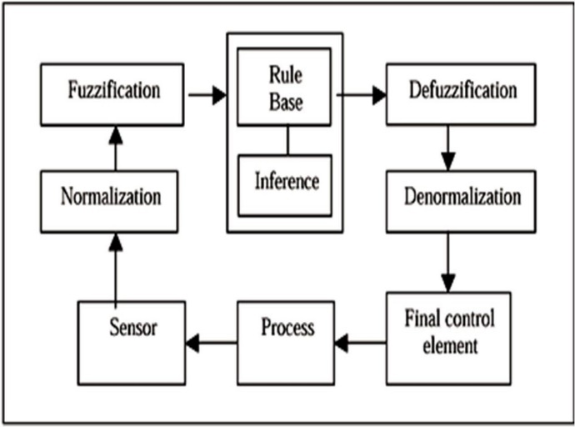

Figure-7: Fuzzy controller block diagram

The advantage of modelling with fuzzy logic is prepared to take action by operators. If the pressure display reaches 115 bar the pressure can be considered as %30. A binary control with a threshold value contact at 120 bars would not be able to apply sufficient operation and would be able to understand the situation all

of a sudden when the pressure value left the non-fuzzy set. On the other hand, operator can be able to recognize critical values. If the operator run into a problem the operator can respond to time taking any necessary counter-measures. To resemble this behaviour, it is needed to use a fuzzy system instead of a binary control.

Fuzzy system is necessarily for part of a technical system which works with numeric values. such as non-fuzzy values at its inputs and outputs. Convenient transformation should be implemented at the input and output of the fuzzy system. This transformation is termed fuzzification and defuzzification.

FUZZIFICATION

Fuzzification is the process of extrication a system input or output into one or more fuzzy sets. Membership functions use triangular and trapezoidal shaped commonly because they are easier to symbolize in embedded systems. Every fuzzy set spans a region of input and output value that is graphed with the membership. Particular input is explicated from this fuzzy set and degree of membership. The membership functions must imbricate to enable smooth mapping of the system. The process of the fuzzification enable the system inputs or outputs to which is denoted in verbal terms .These rules could be executed in a basic manner to express a complex system.

**METHODOLOGIES**

Fuzzy control system design is based on empirical methods. This method show an approach to trial and error. The general process is as follows:

Document the systems executional recognition and inputs, outputs

Document the fuzzy sets for inputs

Document for rule set

Determine the defuzzification methodology

Review test correspond with confirm system specify details as needed

Complete document and put up for sale

**Technology involved**

SİEMENS FUZZYCONTROL++

Using the fuzzy control++ configuration tool consists of two main operations:

* A fuzzy system meeting the disclose necessity must be constituted as a system of basis. In the sequel changes to the fuzzy system are still possible.
* It is necessary to establish a connection with the target system and make the fuzzy system to know inputs and outputs.

GENERATING A FUZZY SYSTEM

The starting point in processing is the problem to be solved with the target system . A project is a fuzzy system determined by the choice of target system its inputs and outputs and its rule basic . To edit a project we can either open an existing project or create a new project. For an existing project we can load its file with the extension *.flp(fuzzy programming language)or *.fcl(fuzzy control language) with open in the file menu. A new project is entitled the as project name “NEW” automatically .First when we save the project we can decide the name to it .

There is a very simple example in which a control must arrange a valve depending on the temperature and pressure. This control is to be executed in a fuzzy system and program for this aim is to be created and transferred in the control unit that is the target system. With the fuzzy control++ tool we could generate the needed system.

This guide explain an introduction to editing a project. We can study a typical project if we fulfil the steps (indented text marked as example) with the fuzzy control++ tool on the PC.

**RESULTS**

The purpose of this function is to approach to stability conditions for open-loop fuzzy systems and stabilization conditions for closed-loop fuzzy systems. We tried the several ways for to find the best solution and this process is attained the correct conclusion that by changing the processing coefficients. It shows for temperature which is equal to zero and one is to describe the rules of the 11 and 10. We have defined the output function equation. This equation is A mathematical tool to build a fuzzy model of a system where fuzzy implications and reasoning are used is presented. The basic foundation of an implication is the description of fuzzy subspace of inputs and its result is a linear input-output relation. The method of definition of a system using its input-output data is then shown**.**

**ANALYSIS**

After that we had programmed the fuzzy logic with ladder diagram on the Siemens it was loaded to the PLC. The PLC and temperature control panel are connected to each other. When the process starts working value of the temperature is rising. The lamp is also getting radiance. After a while the value of the temperature is stabilized to 44 °C. This is close to the middle of the temperature 40-50°C. When we then cooled the lamp by fan the temperature varied between 43-45 °C. If the cooling was very forced it was not possible to maintain the temperature. The input power to the lamp was too small. Although this impact caused the lowering the temperature but the fuzzy system arrange the desired value again.

**CONCLUSION**

Fuzzy systems are showing great guarantee in consumer products, industrial and commercial systems and decision support system. The term fuzzy indicates to the capability od dealing with indefinite or vague inputs. Instead of complex mathematical methods fuzzy logic users must have verbal conditions to define the relationship between the input information and the output information. Fuzzy logic have access to suitable and user friendly front end to improvable control programs. Another advantages are help to designers focus on the functional objectives not on the mathematical equations. Fuzzy logic is a pretty influential tool that is monopolizing most of field and signing thriving applications. The results of testing on the real plant prove which the remedy fuzzy systems controller is able to precision to variation of the reference temperature attention. In a fuzzy controller data pass through a pre-processing block a controller and a post processing block. Pre-processing include of a linear or nonlinear scaling, as well as a quantization when using discrete membership functions and if we talk about continuous membership functions the membership of each input measurement is looked up in a function. When designing the rule base the designer should regard the number of terms set, their shape and their overlap. In this project I have presented the steps required to illustrate fuzzy controllers. Such controllers, when integrated into systems that handle sensitiveness values, require a translation process before and after the reasoning method is applied. Hence the three-step structure of fuzzy controllers: fuzzification, inference and defuzzification. The different stages were explained using an example including temperature control. This is a trivial problem that can be succeeded using many techniques, such as with a classical PID controller.

**REFERENCES**

<http://en.wikipedia.org/wiki/Fuzzy_logic>

<http://en.wikipedia.org/wiki/Defuzzification>

<http://www.ti.com/lit/ds/symlink/lm35.pdf>

labView PID and fuzzy logic toolkit user manual

labView PID and fuzzy logic toolkit user manual

http://www.ni.com/